# Weather App Documentation

## Project Setup and Dependencies

This documentation will guide you through setting up and running the Weather App built with Flutter.

## Dependencies

To ensure that all dependencies are correctly installed, include the following packages in your `pubspec.yaml` file:

cupertino_icons: ^1.0.6

http: ^1.2.1

provider: ^6.1.2

intl: ^0.19.0

flutter_bloc: ^8.1.5

equatable: ^2.0.5

bloc: ^8.1.4

# Running the App

Follow these steps to run the app:

Clone the Repository:

1. Clone the repository to your local machine using:

git clone https://github.com/swangai7178/weather_app.git

Navigate to the Project Directory:

cd weather_app

1. Get the Dependencies:

Install the required packages using:

flutter pub get

1. Run the App:

Start the app on your desired device (emulator or physical device) using:

flutter run

# Project Structure

The project's directory structure is as follows:

├── bloc/

│ ├── currentweatherbloc/

│ │ └── currentweather_bloc.dart

│ ├── daysforecasting/

│ │ └── days_forecast_bloc.dart

│ └── forecastbloc/

│ └── forecast_bloc.dart

├── models/

│ ├── citymodel.dart

│ └── constant.dart

├── screens/

│ ├── detailpage.dart

| | home.dart

| | getstarted.dart

│ └── widget/

│ └── weather_item.dart

└── main.dart

# Key Components

## Bloc for State Management

CurrentWeatherBloc: Manages the state for the current weather data.

DaysForecastBloc`: Handles the state for the daily forecast.

-Forecast Bloc’: Manages the state for hourly forecast data.

## 2. Models

City Model`: Contains city data and manages a list of selected cities.

Constant`: Defines constants used throughout the app.

Current weather model : current

Forecast model: forecast model of the weather

## Screens and Widgets

Home’: The main screen of the app displaying current weather, hourly forecast, and weekly forecast.

-Detail Page’: A detailed view for a selected day’s forecast.

Weather Item’: A reusable widget to display weather parameters like wind speed, humidity, and UV index.

# App Functionality

Home Screen

. Location Dropdown: Allows the user to select a city from the dropdown to view weather data.

Current Weather: Displays the current weather, temperature, and conditions.

Hourly Forecast: Shows the forecast for the days hours.

Weekly Forecast: Displays the forecast for the upcoming week with detailed weather conditions.

Customization

## Adding a New City

To add a new city to the list of available cities, update the `City Model` class in `citymodel.dart`.

Updating Assets

You can replace the assets in the `assets/` directory with your own images. Make sure to update the references in the code if the filenames or paths change.

## Troubleshooting

Dependency Issues :Run `flutter pub get` to ensure all dependencies are installed.

Build Errors: Ensure your Flutter SDK is up to date. Run `flutter upgrade` to update your Flutter installation.

-API Errors: Check your API keys and endpoint configurations if you are fetching live weather data from an external API.

# Conclusion

This documentation covers the basic setup and functionality of the Weather App. For further customization or troubleshooting, refer to the official Flutter documentation or the package documentation for the dependencies used.

INDEX

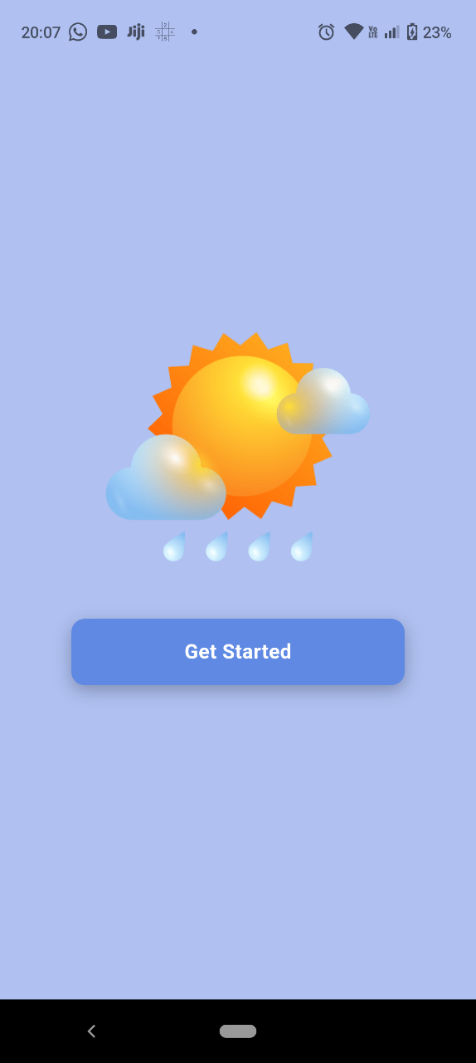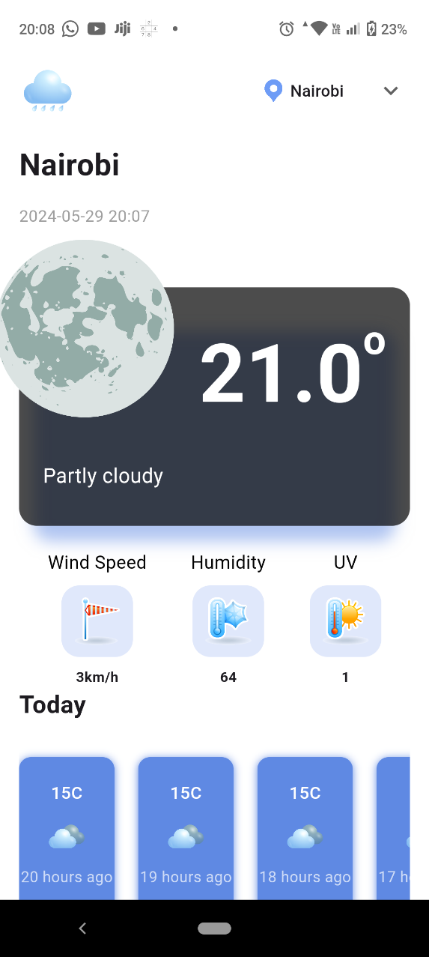

Click on the drop down on the top right to get the list of the city and choose the city that you want to know the weather about you can view 24 hours temperature fluctuation. Scroll down to weekly updates and when you click on one you view on the hourly data of the weather. Click on the tab and it will expand and share more information of the hour selected.

